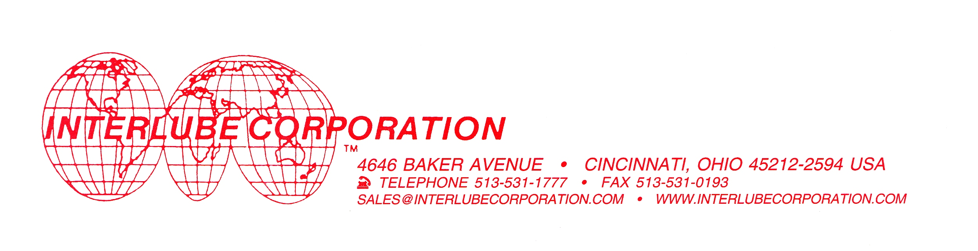

Synthetic Oven Chain & Bearing Lubricant II

Interlube Corporation’s Synthetic Oven Chain & Bearing Lubricant II marks a major advancement in technology for high temperature chain and bearing lubrication. It is manufactured with completely synthetic base stocks, and is enhanced with carefully selected, high performance additives that boost its thermal and oxidative stability for high temperature applications. This results in less coking and varnish formation.

- Completely synthetic - no diluents
- Very high temperature performance
- Very low deposit formation
- Low volatility and reduced consumption
- Superior lubricity
- Excellent adhesion properties
- Meets USDA H-2 requirements (no possibility of contact with food)
- Resist very high temperatures (250°C - 300°C)

Typical Physical Properties

Specific Gravity | 0.97
Flash Point, COC | 292°C / 558°F
Fire Point, COC | 346°C / 655°F
Viscosity @ 40°C | 238 cSt
Viscosity @ 100°C | 18.7 cSt
Copper corrosion (3 hours @ 100°C) | 1a
Four Ball Wear Scar (ASTM D4172) | 0.40 mm
Four Ball Weld Load (ASTM D2783) | 160 kg
Evaporation Loss (ASTM D972) | 1.0%

12817

